') ',-)
'

Academy for Positive Learning Teacher Evaluation System - 2013/2014

Introduction
State law (F.S. 1012.98) specifies, "The purpose of the professional development system is to increase student achievement, enhance classroom instructional strategies that promote rigor and relevance throughout the curriculum, and prepare students for continuing education and the workforce. The system of professional development must align to the standards adopted by the state and support the framework for standards adopted by the National Staff Development Council."

The outcomes expected as a result of the redeveloped evaluation system include:
. D A transition from teacher-centered instruction to student-centered instruction
D Open conversations between observers/evaluators and teachers
D Teachers focused on student learning
D Principals focused on improvement and support ofteaching and learning and tool for developing School Improvement Plans (if applicable)
D A common language regarding instructional practices
D Clear expectations regarding the specific and individualized professional development teachers need to support the learning of all students
D Multiple measures of teacher performance
D Focused, timely and actionable feedback- analysis completed for School Improvement Plan updates.

The components in the teacher evaluation system:
0 Rubric to measure teacher effectiveness
D Trained observers/evaluators
D Formal and inforn1al observation tools with feedback
D Prescriptive professional development
D Mentors for new teachers/induction program D Extensive training program for administrntors D Student achievement data
D Parent Input (Domain 3)

Who conducts the Administrative Apprais_al observation and data reviews?

A trained administrator must conduct the observations. Each administrator will receive certification in the Danielson Framework through ongoing training. The evaluator may be a Principal or Assistant Principal. The observations will be a combination of announced and unannounced occasions. There should be a high correlation between both types of observations.

Peer Evaluations
:)

Peer Evaluations will be conducted by teachers at the school or from other local schools who have been trained in the Danielson Framework through ongoing training.

Walk-Throughs

The Classroom walkthrough (CWT) shall not be used for performance or formal evaluation purposes. CWT will be conducted throughout the year by principals, assistant principals, lead teachers (if applicable), academic coaches, and other designees who have been trained to do CWT. Teachers will have CWT explained annually prior to the implementation of CWT. CWT data collection will be stored in personnel files and its purpose shall be restricted to identifying areas for professional development opp01iunities for individuals and teams.

Teacher Evaluation Weighting Factor Scale

- K-3 teachers and non-content teachers:
  - Admin Appraisal (At least one per year for experienced teachers; two per year for beginning teachers)-25%
  - Peer Eval - 20%
  - SelfEval- 5%
  - District Approved Assessment(s)- 40% (FAIR, RRR) (Current year data to be used)
  - FCAT RIM Whole School VAM - 10% (Cunent year data to be used)
- 4 - 8th grade teachers:
  - Admin Appraisal (At least one per year for experienced teachers; two per year for beginning teachers) -25%
  - Peer Eval - 20%
  - SelfEval- 5%
  - FCAT - 50% Individual VAM score (Last three years data- if available- including current year data to be used)
- Any teacher who falls in both categories:
  - Admin Appraisal (At least one per year for experienced teachers; two per year for begim1ing teachers)-25%
  - Peer Eval - 20%
  - Self Eval - 5%
  - District Approved Assessment(s)- 15% (FAIR, RRR)
  - FCAT RIM Whole School VAM - 10%
  - FCAT - 50% Individual VAM score - 25% (Last three years data - if available - including current year data to be used)

Common Language will be emphasized throughout system
,,.---...,,

,_'--./
J

Common language is defined as a transparent way to talk about instruction that is shared by everyone. It is a well-articulated knowledge base that describes the complexity of teaching and describes key strategies revealed by the research to have a high probability of impacting student learning. It should also describe the instructional context for appropriate use of instructional strategies to have the highest probability for raising student learning. The common language represents what a school or district defines as effective instruction. A common language enables teachers to engage in decision making, professional conversations and growth aimed at improving student achievement. For administrators, a common language provides the means to offer focused formative and summative feedback. It supports administrators in making decisions regarding hiring and selection of teachers, the induction of new teachers, professional development, coaching and support for struggling teachers as well as opportunities to develop career ladders for teachers. A common language is a key improvement strategy that provides the context for aligning all instructional programs.

Full Administrator Observation
The full observation is the primary method for collecting evidence that will be used as a source of data for the smmnative evaluation and provides a rich source of feedback to teachers regarding their instructional practice and professional growth. It is not the summative evaluation. The full observation consists of an observation for a class period (minimum of 30 minutes) as deemed appropriate for various levels (early childhood, primary, inte1111ediate, middle and secondary school). The full observation includes a plaiming and reflection conference with the teacher. These conferences provide a rich opportunity for teachers to reflect upon their practice, engage in a collaborative decision making process and help administrators clarify expectations. Both the planning conference and the reflection conference should be scheduled at the same time that the observation is scheduled and should be conducted in a timely manner (1-5 days preceding and following the observation). The teacher and administrator must sign the observation and the teacher must be provided a copy.

What is the Framework for Teaching? Danielson Model

The Framework for Teaching is organized into 4 Domains and 22 Components. Evidence can be gathered for all Components, although only Domains 2 and 3 are usually observed during a classroom lesson. The Framework for Teaching with its respective Domains, Components, Elements and.levels of Performance is identified as a research-based set of criteria for teaching practice. The Framework for Teaching defines a comprehensive set ofresponsibilities in the teaching profession connected to increased student learning. The Framework for Teaching is displayed on the following pages:

Domain 1: Planning and Preparation
Defines how a teacher organizes the content that the students are to learn-how the teacher designs instruction. All elements of the instructional design-learning activities, materials, assessments, and strategies-should be appropriate to both the content and the students. The components of Domain 1 are demonstrated through the plans that teachers prepare to guide their teaching. The plan's effects are observable through actions in the classroom.

Domain 2: The Classroom Environment
, .,/ ,"J

Consists of the non-instructional interactions that occur in a classroom. Activities and tasks establish a respectf·ul classroom environment and a culture for learning. The atmosphere is businesslike; routines and procedures are handled efficiently. Student behavior is cooperative and non­ disruptive, and the physical environment supports instruction. The components of Domain 2 are demonstrated through classroom interaction and are observable.

Domain 3: Instruction
Consists of the components that actually engage students in the content. These components represent distinct elements of instrnction. Students are engaged in meaningful work that is important to students as well as teachers. Like Domain 2, the components of Domain 3 are demonstrated through teacher classroom interaction and are observable.

Domain 4: Professional Responsibilities
Encompasses the professional's role outside of the classroom. These roles include professional responsibilities such as self-reflection and professional growth, in addition to contributions made to the schools, the district, and to the profession as a whole. The components in Domain 4 are demonstrated tlu·ough teacher interactions with colleagues, families, and the larger community.

"Because teaching is complex, it is helpful to have a road map through the territory, structured around a shared understanding of teaching." Charlotte Danielson Formative and Summative

Aspects of the Framework for Teaching

The formative aspect of the Framework for Teaching model promotes professional growth through teacher self-assessment, goal setting and professional reflection. The summative aspect of the model uses classroom observations, teacher conferences with the supervising administrator, and a review of the attainment of individual goals to document professional growth and effective teaching practice.
The objective of the formative aspect is to improve professional practice. This is best achieved when learners take ownership of their learning goals that are established through thoughtful self-assessment, personal reflection on teaching practices, and specific feedback based upon standards of teaching practice.
The purpose of the summative aspect is to provide a comprehensive assessment of a professional educator's practice which validates professional growth and competence, provides public assurance of teaching effectiveness and provides evidence-based judgments about professional prac ice.

Comprehensive Annual Review - Continuous Improvement Practice/Regular Monitoring of Evaluation System

After a comprehensive annual review, staff will meet with the Administration and the Board of Directors to discuss any recommendations to update the Instructional Evaluation System. The AFPL system supports the school improvement plan by focusing on the development of highly effective skills. These skills are specified in the Charlotte Danielson Model and monitored by principals through the evaluation process. At present, the school is developing indicators for the comprehensive annual review which will be tabulated to analyze end of the year evaluations and use those results to impact school improvement plans. Individualized professional development is central to the entire evaluation system.

AFPL's P - ssional Development plan is aligned to Charlotte Danielson'--i:.'ramework for Effective Teaching. Professional development-;"" offered annually an'-r aligns with the components of the Danielson Framework. AL_ achers and leaders will have multiple opp01iunities to exam;_ )modify, and implement professional development opportunities that are identified in their individual Professional Growth Plan thus creating a continuous improvement cycle.

Through the development of a comprehensive mmual review, the AFPL staff and Administration will review data_ collected and make recommendations to the School Board of Directors regarding its use. The review will occur on an annual basis as will the recommendations that follow it. In addition, teachers and principals will have access to the data analysis and use it to improve their practice as it relates to effective instruction.

The school will perform a comprehensive annual review after the initial year of implementation and each following year. Data will be collected using the following methods:
- Questionnaire to assess teacher/leader perceptions of adequacy of training, understanding of the system, fairness of the process, and impact of the new process on teaching and student learning;
- Interviews of selected teachers/leaders to gather feedback on system implementation m1d identify necessary adjustments;
- Correlation of teacher performance ranking and student performance data;
- Impact of Professional Growth Plans on teacher/student learning;
- Trend data on utilization of online/face-to-face professional development offerings;
- Patterns of performm1ce on vm·ious components of frmnework;
- Review and feedback on forms, rubric language, processes, and support materials for recon1111ended revisions.

The results of the annual review of the Instructional Evaluation System will be tabulated and presented in an mmual report to the School Board of Directors at the annual Board meeting. At that time the Board will discuss changes to the Evaluation System and recommend changes to be made or send to committee for further review and discussion.

Description of the Four Rating Labels
The rating labels for the Instructional Practices evaluation component are described below as well as the rubrics and the weighting scales/scoring system.

Highly Effective: Level of performance that shows that the teacher has mastered all the underlying concepts of the Component and the classroom
:functions as a community of learners with students assuming responsibility for their learning.

Effective: Level of performance that shows that the teacher has a thorough knowledge of the concepts underlying the Component. Students are engaged in learning. This level of performance represents successful, professional, and proficient teaching. Teachers at this level have mastered the work of teaching while working to confomally improve their practice.

Needs Improvement or Developing: Level of performance that shows that the teacher understands the concepts underlying the Component and attempts to implement the elements. However, the implementation is sporadic, intennittent, or otherwise not entirely successful. If a teacher is identified on one of the four domains as Developing or Needs Improvement, a Lem·ning Professional Growth Plan must be developed. (pp. 7 - 10)

Unsa isfa< y: Level of p rforn:iance that shows that the teacher does 101--,?ersta°:d the concepts underlying the Component. This level.. 1• 0 \1..resents teachmg thac1s below the hcensmg standard of "do no harm" and reqmre -- .:cervent10n. \ )

Evaluation Rubric
The evaluation rubric has been adapted from the Danielson Framework for Teaching model and consists of the four Domains:

- Planning and Preparation
- Classroom Environment
- Instruction
- Professional Responsibilities

Each of the twenty-two Components is graded on four proficiency levels: Highly Effective, Effective, Needs Improvement or Developing (teachers with 0-3 years of experience and teachers new to the school) and Unsatisfactory.

Learning Professional Growth Plan and Beginning Teachers/Newly Hired
All beginning teachers (0 to 3 years experience or new to the school) must develop a Leaming Professional Growth Plan (pp. 7 - 10) and if required by the District to obtain permanent certification must complete the state approved Begi1ming Teacher Supp01i Program - currently Florida Performance Measurement System (FPMS) based on the indicators identified in FEAPs, Rule 6A-5.065. These teachers will be assigned a mentor to conduct additional support observations targeting the FEAPs. Any teacher evaluated as Needs Improvement on any of the Four Domains will complete a Learning Professional Growth Plan.

Training of Evaluation System

Initially staff will be introduced to the Instructional Evaluation System through on site staff development, staff weekly meetings and on line webinars. This will include the tools used for the Evaluation System, observation expectations, and review of conunon language of instruction to be used. All staff will be fonnally trained on the use of the Danielson Framework/Model beginning in the Summer 2013 by ce1iified professional developers and will receive refresher courses thereafter, ammally or as needed.

Use of Evaluation System Review to Update School Improvement Plan
If the school is required to submit a School Improvement Plan, the Board of Directors, staff, parents, and community members involved will review the Teacher Evaluation System aimually for effectiveness. Staff will be given a survey to be used to help evaluate the system. Along with the comprehensive annual review, results will be shared with the School Improvement Co1mnittee to be included in the aimual plan. The committee will analyze results from the comprehensive annual review, staff surveys, and student data to set school wide goals for the following year.

t'." .-- '"" 2
 | Performance rating
 | Unsatisfactory  (0 points)  ··· | Needs Improvement/ Develonine: (1 noints)  y,;;1, ·'":'/ %J/fj0;/,:;T; |  | Effective  (2 points)  f?2i£i,;;'.. | },'{ | Highly Effective
.o::7,iiY!.P:·;;?J:/!!iJF;;,y< < ·• | ·Y<;,1.-./,*vr
 |  | The teacher's plans and practice reflect some awareness of the important concepts in the discipline, prerequisite relationships between them, and the instructional practices specific to that discipline. | --·  The teacher's plans and  practice reflect solid knowledge of the content, prerequisite relationships between important concepts, and the instructional practices specific to that discipline. |  | The teacher's plans and practice reflect extensive knowledge of the content, the structure of the discipline and instructional practices. The teacher actively builds on knowledge of prerequisites and misconceptions.  The teacher stays abreast of emerging research areas, new and innovative methods and incorporates them into lesson plans and instructional strategies.
la. Demonstrating | The teacher's plans and
Knowledge of Content | practice di s p I a y little
and Pedagogy | knowledge of the content,
(Component weight: 4%) | prerequisite relationships  between different aspects of
 | the content, or the
 | instructional practices_
 | specific tothat
 | discipline.
 | Teacher makes content
 | errors or does not correct
 | errors.
 | Subject is off
 | topic/irrelevant
 | D | D | D |  | D
Elements include:
Knowledge of content and the structure of the discipline Knowledge of prerequisite relationships
Knowledge of content-related pedagogy
Self-Rating Peer Rating
Administrator rating
lb. Demonstrating Knowledge of Students  (Component weight: 4%) | The teacher demonstrates little or no knowledge of students' backgrounds, cultures, skills, learning levels / styles, language proficiencies, interests, and special needs, and does not seek such understanding. | The teacher indicates the importance of understanding students' backgrounds, cultures, skills, learning levels / styles, language proficiencies, interests, and special needs, and attains this knowledge for the class as a whole. | The teacher actively seeks knowledge of students' backgrounds, cultures, skills, learning levels / styles, language proficiencies, interests, and special needs, and attains this knowledge for groups of students. |  | The teacher actively seeks knowledge of students' backgrounds, cultures, skills, learning levels / styles, language proficiencies, interests, and special needs from a variety of sources, and attains this knowledge of  individual students.
 | D | D | D |  | D
Elements include:
Knowledge of child and adolescent development Knowledge of the learning process
Knowledge of students' skills, knowledge, and language proficiency
Knowledge of students' interests and cultural heritage Knowledge of students' special needs
Self-Rating
Peer Rating Administrator Rating
le. Setting Instructional Outcomes  (Component weight: 2%) | Instructional outcomes are unsuitable for students, represent trivial or low- level learning, or are stated only as activities. They do  not permit viable methods of assessment. | Instructional outcomes are stated as goals and activities reflecting inconsistent levels oflearning, only some of which permit viable methods of assessment. Outcomes reflect more than one type of learning. | h1structional outcomes are stated as goals reflecting high-level learning and curriculum standards. The outcomes are suitable for most students in the class, represent different types of learning, and can be assessed. |  | Instructional outcomes are stated as goals that can be assessed, reflecting rigorous learning and curriculum standards taking into account of the needs of individual students.
 | D | D | D |  | D
Elements include:
Value, sequence, and alignment
Clarity Balance
Suitability for diverse learners

..·····i- f;ii;1::2iJ;i•i ' i

)

Self-Rating

Peer Rating
IA .. Dn+;no
ld. Demonstrating | The teacher demonstrates | The teacher demonstrates | The teacher is fully aware | The teacher actively seeks
Knowledge of Resources and Technology | little or no familiarity with  available resources and | some familiarity with  available resources and | of the available resources  and technology and | additional resources and  technology and incorporates
(Component weight: 2%) | technology to enhance instruction. | technology to enhance instruction | incorporates them to enhance instruction. | them to enhance instruction.
 | D | D | D | D
Elements include:
Resources and technology for classroom use
Resources and technology to extend content knowledge and pedagogy
Resources and technology for students
Self-Rating

Peer Rating
IA - .. , "" .,. D nt;no

)
 | Performance
 | Unsatisfactory  (0 points)  Learning activities, materials, and/or resources are not suitable to student instructional goals. Thf do 1not follow an organize progression.  Instructional groups do not s'IBport insquctional goals and o er no variety.  The lesson has no defined structure. or the structure is chaotic. time allocations are unrealistic. | Needs Improvement (1 points)  Few of the learnin& activities are suitable to stu ents and instructional 0 oals.  Progression o1activities is uneven. Materials and resources are minimally supportive.  Instructional groups lack differentiation based on student need.  IThe lesson has a recognizable structure. Most time allocations are reasonable. | Effective  (2 points)  Most learning activities are suitable to students and instructional goals.  Progression of activities is even. The majority of the materials and resources support instruction and are meaningful.  Instructional groups are differentiated based on student need.  The lesson has a clearly defined structure. Time allocations are reasonable. | Highly Effective (3 points)  Learning activities are relevant to students and instructional goals. They progress coherently, producing a unified whole and are reflective of current professional research.  All material and resources support instructional goals, and engage students in meaningful learning. There is evidence of student participation in selecting or adapting materials.  Instructional groups are differentiated by student needs. Students are involved in the selection process for instructional grouping where appropriate.  The lesson structure is clear and allows for differing pathways according to student needs.
le. Designing Coherent Instruction

(Component weight: 4%)
 | D | D | D | D
Elements include:
Leaming activities
Instructional materials and resources Instructional groups
Lesson and unit structure
Self-Rating Peer Rating
Administrator Rating

2

If. Designing Student | The teacher's plan for | The teacher's plan for student | The teacher's plan for | The teacher's plan for
Assessments | assessing student learning | assessment is partially | student assessment is | student assessment is aligned
(Component weight: 4%) | contains no clear criteria or  standards, is poorly aligned | aligned with the instructional  outcomes, lacking criteria, | generally aligned with the  instructional outcomes, uses | with the instructional  outcomes and shows
 | with the instructional | and/ or inappropriate for | clear criteria, and is | evidence of student
 | outcomes, or is inappropriate | some students. The teacher | appropriate to the needs of | contributions to the
 | for many students. The | uses assessment results to | students. The teacher uses | development of the criteria
 | results of assessment have | plan for future instruction for | assessment results to plan | and standards. The teacher
 | minimal impact on the design | '11e class as a whole. | for future instruction for | may have adapted
 | of future instruction. |  | groups of students. | assessment for individuals,
 |  |  |  | and the teacher uses
 |  |  |  | assessment results to plan
 |  |  |  | future instruction for
 |  |  |  | individual students.
 | D | D | D | D
Elements include:
Congruence with instructional outcomes
Criteria and standards
npc;,,n nf . .. OSPeemPnte
Self-Rating

Peer Rating

Administrator Rating

Performance

) 2a. Creating an Environment of
Respect and Rapport
Unsatisfactory
(0 points)

Classroom interactions, both between the teacher and students and/or among students, are negative,
Needs Improvement
(1 points)

Classroom interactions are generally appropriate and free from conflict, but may be characterized by
Highly Effective (3 points)

Classroom interactions are respectful, reflecting genuine caring and sensitivity to students'
Effective
(2 points)
Classroom interactions are polite and respectful, reflecting caring, and are appropriate to the cultural and developmental differences among groups of students.

(Component weight: 5%) inappropriate, or insensitive
to students' cultural backgrounds and are characterized by sarcasm, put-downs, or conflict.
D
D
D
Elements include:
Teacher interaction with students Student interactions with other
occasional displays of insensitivity or lack of responsiveness to cultural or developmental differences amorig students.
cultures and levels of development. Students themselves ensure high levels of civility among members of the class.

D

Self-Rating Peer Rating
Administrator Rating

)
_/_

3

2b. Establishing a  Culture for Learning (Component weight: 5%) | Teacher or students convey a  negative attitude toward the content suggesting that the content is not important or is mandated by others.  Students demonstrate little or no pride in their work. They seem to be motivated by the desire to complete a task rather than do high-quality work.  Instructional goals and activities, interactions, and the classroom environment convey only modest expectations for student achievement | Teacher communicates  importance of the work but with little conviction and only minimal student engagement.  Students minimally accept the responsibility to "do good work" but invest little of their energy in the quality of the work.  Instructional goals and activities, interactions, and the classroom environment convey inconsistent expectations for student achievement. | Teacher conveys genuine  enthusiasm for the subject, and students demonstrate consistent commitment to its value.  Students accept teacher insistence on work of high quality and demonstrate pride in the work  Instructional goals and activities, interactions, and he classroom environment convey high expectations for student achievement. | Student demonstrate through  their active participation, curiosity, and attention to detail that they value the content's importance.  Students take obvious pride in their work and initiate improvements in it, for example, by revising drafts of their own initiative, helping peers, and ensuring that high quality work is displayed.  Both students and teacher establish and maintain through the planning of learning activities, interactions, and the classroom environment, high expectations for the learning of all students.
 | D | D | u | D
Elements include: Importance of the content
Expectations for learning and achievement
Self- Rating Peer Rating
Administrator Rating
2c. Managing Classroom  Procedures  (Component weight: 2.5%) | Student not working with  the teacher are not productively engaged in learning. Much time is losing during transitions. Materials are handled inefficiently, resulting in loss of instructional time. Considerable instructional time is loss in performing non instructional duties. Volunteers and paraprofessionals have no clearly defined duties or do nothing most oftl1e time. | Tasks for group work are  partially organized, resulting in some off-task behavior when teacher is involved with one group. Transitions a sporadically efficient, resulting in some loss of instructional time. Routines for handling materials and supplies function moderately well. Systems for performing non instructional duties are fairly efficient, resulting in little loss of instructional time. Volunteers and paraprofessionals are productively engaged during portions of class time but require frequent supervision. | Task for group work are  organized and groups are manage so most students are engaged at all times.  Transitions occur smoothly, with little loss of instructional time. Routines for handling materials and supplies occur smoothly, with little loss of instructional time. Efficient systems for perfom1ing non instructional duties are in place, resulting in minimal loss of instructional time. Volunteers and paraprofessionals are productively and independently engaged during the entire class. | Grouping working  independently are productively engaged at all times with students assuming responsibility for productivity. Transitions and routine for handling materials and supplies are seamless, with students assuming some responsibility for efficient operation. Systems for performing non instructional duties are well established, with students assuming considerable responsibility for efficient operation.  Volunteers and paraprofessionals make a substantive contribution to the classroom environment
 | D | D | D | D
Elements include:
Management of instructional groups
Management of transitions
Management of materials and
supplies Performance of non- instructional duties
Supervision of volunteers and paraprofessionals
Self- Rating
Peer Rating Administrator Rating
4

2d. Managing Student | No standard of conduct | Standards of conduct | Standard of conduct are clear | Standards of conduct are
Behavior | appear to have been | appear to have been | to all students. | clear to all student and
(Component weight: 5%) | established, or students are  confused as to what the | established for most  situations and most students | Teacher consistently | appear to have been  developed with student
 | student are. | seem to understand them. | monitors student behaviors | participation.
 | Student behavior is not | Teacher is generally aware | Teacher response to | Monitoring by teacher is
 | monitored, and teacher is | of student behavior but may | misbehavior is appropriate, | subtle and preventive.
 | unaware of what students | miss the activities of some | successful and respects the | Students monitor their own
 | are doing. | students. | student's dignity | and their peers' behavior,
 |  |  |  | correcting one another
 | Teacher does not respond to | Teacher attempts to respond |  | respectfully.
 | misbehavior, or the response | to student misbehavior but
 | is inconsistent, overly | with uneven results, or |  | Teacher response to
 | repressive or does not | student behavior is |  | misbehavior is highly
 | respect the student's dignity. | occasionally disruptive. |  | effective and sensitive to
 |  |  |  | students' individual needs.
 | LJ | D | D | D
Elements include:
Expectations
Monitoring of student behavior Response to student misbehavior
Self-Rating Peer Rating
Administrator Rating

I
 | Performance
 | Unsatisfactory  (0 points) |  | Needs Improvement (1 points) | Effective  (2 points) | Highly Effective  (3 points)
2e. Organizing Physical Space  (Component weight 2.5%) | The classroom is unsafe, or the furniture arrangement is not suited to the lesson activities, or both.  Teacher uses physical and/or available echnology resources poorly, or learning is not accessible to some students. |  | The classroom is safe, and classroom furniture is adjusted for a lesson, or if necessary, a lesson adjusted to the | The classroom is safe, and the furniture arrangement is conducive to learning activities. | The classroom is safe, and students adjust the furniture to advance their own purposes in learning.
 |  |  | furniture, but with  limited effectiveness. | Teacher uses physical | Teacher and students
 |  |  |  | and/or available | are physical and/or
 |  |  | Teacher uses physical and/or available technology resources adequately, and at least essential learning  is accessible to all | technology resources skillfully and learning is accessible to all. | available technology resources optimally, and both ensure that learning is accessible to all.
 |  |  | students.
 | D |  | LJ | D | D
Elements include:  Safety and accessibility  f> nc,PmPnt nffom;t.,rP nn nep |  | T
Self- Rating Peer Rating
Administrator Rating

J
/

5

Performance
Unsatisfactory Needs Improvement Effective Highly Effective
(0 points) (1 points) (2 points) (3 ooints)
"i?:i<,,; ,"""" ·)!,;;>: ..,, ;:,\•·:······ •.. . .:H. ••,: :;::,.,f:ri+'·'· .....: ...,. _.,..
y;;.c "" J;;:;;;:iitiYlWI ·:oc:;:< '"""· ·• c:%1': .e ··F·h;;
,:0;:
3a. Communicating with Teacher directions and Teacher directions and Teacher directions and Teacher directions and Students procedures are confusing to procedures are clarified procedures are clear to procedures are clear to students. The teacher does after initial student students. Teacher students and anticipate
(Component weight: 9%) not communicate lesson confusion or are excessively communicates lesson possible student
objective. detailed. Teacher objective and explains its misunderstandings. communicates lesson importance to the lesson.
Teacher's spoken language is objective. Teacher's spoken and inaudible and written Teacher's spoken and written language is correct language is illegible. Spoken Teacher's spoken language written language is clear and expressive, with well- or written language may is audible and written and correct. Vocabulary is chosen vocabulary that contain grammar and syntax language is legible. Both appropriate to students' age enriches the lesson.
errors. Vocabulary may be are used correctly but and interests. inappropriate, vague, or used limited, or not appropriate
incorrectly, leaving students to students' age or confused. background.

D D D D
Elements include: Expectations for learning Directions and procedures Explanations of content
Use of oral and written language
Self- Rating Peer Rating
Administrator Rating
3b. Using Questioning Teacher's questions are Teacher's questions are a Most of the teacher's Teacher's questions are of and Discussion virtually all low-level and combination of high and questions are of high uniformly high quality,
Techniques of poor quality. They low quality posed in rapid quality. Adequate time is with adequate time for (Component weight: 9%) elicit limited student succession. Teacher available for students to students to respond.
response. Interaction attempts to engage respond participate; Students formulate many between student and students in the discussion classroom interaction questions. Students teacher is recitation style, with limited success. represents true discussion. assume responsibility for with teacher mediating all the continuance of the
answers. Only a few discussion, initiating
students participate in topics and making
discussion. unsolicited contributions.

D D D D
Elements include Quality of questions Discussion techniques Student participation
Self-Rating Peer Rating
Anministrntnr RHtino

)
j

6

3c. Engaging Students in  Leaming  (Component weight: 9%) | Activities and assignments, materials, and groupings of students are inappropriate for the instructional outcomes, students' cultures,  maturation or age levels. | Activities and assignments, materials, and groupings of students are partially appropriate for the instructional outcomes, students' cultures, maturation or  age levels. The lesson has | Activities and assignments, materials, and grouping of students are appropriate for instructional outcomes, students' cultures,  maturation or age levels. | k'\.ctivities, assignments, and materials  lA.re suitable to the instructional goals. Students are engaged and able to adapt materials to  meet learning outcomes.
 | The lesson has no | recognizable structure but | The lesson structure is | Grouping of students are
 | structure or is poorly | is unclear. | coherent and is paced | appropriate for the
 | paced.  Representation of content | Representation of content is inconsistent in quality. | appropriately.  Representation of content | instructional outcomes, students' cultures,  tmaturation or age levels.
 | is unclear. Teacher uses |  | is appropriate and is | The lesson structure is
 | poor examples and |  | aligned with students' | highly coherent, allowing
 | analogies or is incorrect. |  | knowledge and | for reflection ad closure
 |  |  | experiences. | as appropriate. Pacing
 |  |  |  | demonsu·ates
 |  |  |  | differentiation based on
 |  |  |  | needs.
 |  |  |  | Representation of content
 |  |  |  | is outstanding and is
 |  |  |  | aligned with students'
 |  |  |  | knowledge and
 |  |  |  | experiences.
 | D | D | D | D
Elements include:
Activities and assigmnents Grouping of students
Use of instructional materials, resources and technology (as available)
Structure and pacing
Self-Rating-
Peer Rating- Administrator Rating-

7

 | Perfor |  | mance
 | Unsatisfactory  (0 points) | Needs Improvement  (1 points) | Effective  (2 ooints) | Highly Effective  (3 ooints)
3d. Using Assessment in | Feedback is either not | Quality offeedback is | Feedback is consistent and | Feedback is consistently
Instruction | provided or is of poor | inconsistent. Timeless of | informative. Feedback is | high quality. Provision is
(Component weight: 9%) | quality. Feedback is not  provided in timely manner. | feedback is inconsistent. | consistently in a timely  manner. | made for students to use  feedback in their learning.
 |  |  |  | Feedback is consistently
 |  |  |  | provided in a timely manner.
 |  |  |  | Students make meaningful
 |  |  |  | use offeedback in their
 |  |  |  | learning.
 | D | D | D | D
Elements include:
Assessment criteria
Monitoring of student learning Feedback to students
Student self-assessment and monitoring of progress
Self-Rating Peer Rating
!Administrator Rating
3e. Demonstrating | The teacher adheres rigidly | The teacher attempts to | The teacher promotes | The teacher successfully akes substantive adjustments to a lesson when inecessary. Teacher seizes opportunities to enhance learning, building on spontaneous events. The eacher consistently utilizes an extensive repertoire of instructional strategies.
Flexibility and Responsiveness  (Component weight: 4%) | to an instruction plan, even when engagement is lacking. Teacher ignores student questions or interests. | adjust the lesson and respond to student question with moderate success. The eacher accepts responsibility for student  success, but has only a | successful learning, making adjustments as needed to plans and accommodating student questions, needs, and  interests. Teacher
 | When a student has | limited repertoire of | accommodates for students
 | difficulty learning, the | instructional strategies to | with special needs or
 | teacher blames external | use. | difficulties with a repertoire
 | factors in the student's life to |  | of instructional strategies.
 | [justify non-responsiveness to
 | needs. | In response to student
 | The teacher does not re- teach. | progress, teacher re-teaches, as appropriate.
 | D | D | D | D
Elements include: Lesson adjustment Response to students
Persistence
Self-Rating Peer Rating
Administrator Rating

) '

8

 | Performance
 | Unsatisfactory  (0 points) | Needs Improvement  (1 points) | Effective  (2 noints) | Highly Effective
3f. Using Assessment in | Assessment is not used in | Assessment is occasionally | Assessment is regularly used | Assessment is consistently
Instruction | instruction, either through | used in instruction, either | in instruction, through self- | used in a meaningful manner
(Component weight: 4%) | monitoring of progress by  the teacher or student. | through some monitoring of  progress ofleaming by the | assessment by students,  progress monitoring of | in instruction, through  student involvement in
 | Teacher does not provide | teacher and/or students. | learning by the teacher | establishing the assessment
 | assessment criteria used to | Teacher provides minimal | and/or students. Teacher | criteria, self-assessment by
 | evaluate student work. | assessment criteria used to | provides sufficient | student, monitoring of
 |  | evaluate student work, | assessment criteria used to | progress by both students
 |  |  | evaluate student work. | and teachers. Teacher
 |  |  | Assessments provide | provides detailed assessment
 |  |  | students with multiple ways | criteria used to evaluate
 |  |  | to demonstrate mastery | student work. The
 |  |  |  | assessments provide students
 |  |  |  | with multiple ways to
 |  |  |  | demonstrate mastery and
 |  |  |  | multiple opportunities during
 |  |  |  | the unit to demonstrate
 |  |  |  | mastery
 | D | D | D | D
Elements include:
Criteria Assessment
Monitoring of student learning Student self-assessment and Monitoring of progress
Self-Rating

Peer Rating

Administrator Rating

/

Performance
Unsatisfactory  (0 points)  ' ' " ' ' '{f;1ji1:2 ffJ ffi[:/t; :}  The teacher does not know if the lesson was effective or how it could be improved. | Needs Improvement  (1 points)  _'..  '/t;t;,!i.'i  The teacher provides a partially accurate description of the lesson's effectiveness  but does not cite specific | Effective  (2 ooints)  :.";' .w ..••  o•u.,m n  The teacher provides an accurate description of the lesson, citing specific  evidence. The teacher | Highly Effective  (3 points)  "":if 1? Ii,:fiM··""':;,,,xiii?  The teacher's reflection on the lesson is thoughtful and accurate, and many specific  examples are used to
 | evidence. The teacher | makes some specific | establish that goals were
 | makes only general | suggestions as to how the | accomplished, citing specific
 | suggestions as to how the | lesson might be improved. | evidence. The teacher draws
 | lesson might be improved. |  | on an extensive repertoire to
 |  |  | suggest alternative strategies
D | D | D | and predicts the likely success of each.  D

v4;::;; ;{ .9/4![<}/' ,H/ ' ,,, •. ;;
4a. Reflecting on Teaching

(Component weight: 3%)

Elements include: Accuracy
Use in future teaching Self-Rating
Peer Rating

Administrator Rating
The teacher's systems for  maintaining both | The teacher's system for  maintaining both | The teacher's systems for  maintaining both | The teacher's systems for  maintaining both
instructional and non- | instructional and non- | instructional and non- | instructional and non-
instructional records are | instructional records are | instructional records are | instructional records are
either nonexistent or in | rudimentary and only | accurate, efficient, effective, | accurate, efficient, and
disarray, resulting in errors | partially effective. | timely and reflect student | effective timely and reflect
and confusion. |  | progress in reaching specific | student progress in reaching
 |  | grade level benchmarks. | specific grade level
 |  |  | benchmarks. The system is
 |  |  | readily understood and
D | D | D | transparent.  D

4b. Maintaining Accurate Records

(Component weight: 3%)

Elements include:
Student completion of assignments and Student progress in learning Non instructional records
Self-Rating

Peer Rating Administrator Rating
4c. Communicating with The teacher's The teacher adheres to The teacher communicates The teacher's
Families communication with school procedures for frequently with families and communication with families families about the communicating with families successfully engages them is frequent and sensitive to
(Component weight: 4%) instructional program or and makes modest attempts in tl1e instructional cultural traditions; students
about individual students is to engage families in the program. Information to participate in the
sporadic or culturally instructional program. families about individual communication. The teacher inappropriate. The teacher However, communications students is conveyed in an successfully engages
makes no attempt to engage are not always appropriate. appropriate manner. families in the instructional families in the instructional Responses to parent Responses to parent program as appropriate. The program. Teacher does not concerns are minimal. concerns occur as needed. teacher is proactive in respond to parent concerns. dealing with parent concerns
D D D D
Elements include:
Information about the instructional program
/
Information about individual students
Engagement of families in the instructional program Self-Rating
Peer Rating
I, .. "Rstina
9

,----...........,
4d. Participating in a | The teacher avoids | The teacher becomes | The teacher participates | The teacher makes a
Professional | participating in a | involved in the professional | actively in the professional | substantial contribution to
Community | professional community or in | community and in school | community or in school or | the professional community
(Component weight: 3%) | school and district events  and projects; rarely | and district events and  projects when specifically | district events and projects,  actively seeks out | and to school and district  events and projects,
 | collaborates with colleagues; | asked, makes some effort to | opportunities to collaborate | collaborates with
 | and relationships with | collaborate with colleagues, | with others, and maintains | / coaches others through
 | colleagues are negative or | and relationships with | positive and productive | difficult situations, and
 | self-serving. | colleagues are cordial. | relationships with | assumes a leadership role
 |  |  | colleagues. | (formal or informal) with
 |  |  |  | colleagues.
 | D | D | D | D
Elements include:
Relationships with colleagues
Involvement in a culture of professional inquiry Service to the school
Participation in school and district projects
Self-Rating

Peer Rating
/J. .. ,po+; .,.
4e. Growing and | The teacher does not | The teacher participates in | The teacher seeks out | The teacher actively pursues
Developing | participate in professional | professional development | opportunities for | professional development
Professionally | development activities and | activities that are convenient | professional development | opportunities and initiates
(Component weight: 3%) | makes no effort to share  knowledge with colleagues. | or are required and makes  limited contributions to the | based on an individual  assessment of needs and | activities to contribute to  the profession. In addition,
 | The teacher is resistant to | profession. The teacher | actively shares expertise | the teacher seeks feedback
 | feedback from supervisors | accepts, with some | with others. The teacher | from supervisors and
 | or colleagues. Teacher does | reluctance, feedback from | welcomes feedback from | colleagues. Teacher
 | not actively enhance | supervisors and colleagues. | supervisors and colleagues. | consistently seeks
 | knowledge or skills. | Teacher makes minimal | Teacher make significant | opportunities to enhance
 |  | effort to enhance knowledge | effort to enhance knowledge | knowledge or skills.
 |  | or skills. | or skills.
 | D | D | D | D
Elements include:
Enhancement of content knowledge and pedagogical skill Receptivity to feedback from colleagues
Service to the profession
Self-Rating

Peer Rating Administrator Rating

')

)
 | Performance
 | Unsatisfactory  (0 points) | Needs Improvement  (1 points) | Effective  (2 noints) | Highly Effective
4f. Showing | The teacher is inconsistent | The teacher strives to | The teacher regularly | The teacher is a model for
Professionalism | in adhering to professional | adhere to standards for | adheres to and models | professional conduct and
standards of conduct. The
 |  | professional conduct and | standards for professional | overall performance
(Component weight: 4%) | teacher exhibits poor attendance and punctuality, compliance with school policies, procedures and timelines  The teacher has difficulty demonstrating respect, responsibility, honesty and integrity; requires frequent feedback from colleagues and administrators and does not work cooperatively with school staff.
 |  | overall performance | conduct and overall | requirements including
 |  | requirements, including | performance requirements, | attendance of punctuality.
 |  | attendance and punctuality. | including attendance and
 |  | The teacher complies minimally with school and district regulations, doing  just enough to get by. | punctuality.  The teacher complies with school and district policies, procedures and timelines. | The teacher complies fully and voluntarily with school and district policies, procedures and timelines.  The teacher performs
 |  | The teacher strives to develop behaviors that model the values of respect, responsibility, honesty and integrity. However, he or she requires some support supervision. He or she responds appropriately to  and acts upon feedback. He | Performs with minimal  supervision.  The teacher helps members of school community understand and adhere to these professional obligations, responds well to and acts upon feedback and  works cooperatively with | independently.  The teacher helps members of school community understand and adhere to professional obligations.  She/he actively seeks, responds well to and acts upon feedback
 |  | or she works cooperatively | school staff.
 |  | with school staff most of the
 |  | time.
 | D | D | D | D
Elements include:
Integrity and ethical conduct Service to students Advocacy
Demonstrates logical thinking and makes practical decisions
Attendance Punctuality
Compliance with school and district regulations
Self-Rating  Peer Rating  Administrator Rating |  | '

i
\ .. /I
ACADEMY FOR POSITIVE LEARNING

ENHANCING TEACHER EFFECTIVENESS
Working together to help students achieve by helping teachers succ,

Informal Observation Form
(To be used by Administrators for Classroom Walk-Through Observations and/or by Peer Observers/Evaluators (Content Area Specialists) for Classroom Pop-In Observations)

Teacher Nam --------.,. ---- School /location ---------
Observer Name------------ Role 7-:--7"""-:----:--:--::---=-----------
' (Principal, AP, Peer Evaluator/GAS)

Observation Date-----
Subject Area/Grade Observed ---------

Beginning Time _ Ending Time-----------
Domain 1: Planning and Preparatic;m
1 c. Setting lnstructional Outcomes
Instructional Objective: 0 .Posted/written correctly O Posted/written incorrectly O Not posted
0 Reviewed verbally during instruction (unable to post, i.e., PE/AG class activity)

Instructional Purpose Evident to Most Students: 0 Yes O No
How? 0 Teacher elicited feedback O Observer elicited feedback O Students provided
Identifying Grouping Format: O Whole group O Individual o Small group o Paired (may select more than one)
Comments:

Domain 2: Classroom Envi-ronrnent
2b. Establishing a·Culture for Learning
Relevant, rigorous, and current work displayed: | 0 |  | Yes | 0 No 0 NIA
Students working on relevant and rigorous work: | 0 |  | Yes | 0 N9 0 NIA
2c. Managing Classroom Procedures
Procedures posted: | 0 |  | Yes | 0 No
Procedures implemented and/or evident: | 0 |  | Yes | 0 No
Transitions: | 0 |  | Smooth | 0 Disjointed
Instructional Time Lost: | 0 |  | Yes | 0 No
2d. Managing Student Behavior
0 Respectful desists O Inconsistent desists |  | 0 | Punitive | desists 0 None needed
Negative impact on learning: |  | 0 | Yes | 0 No
) Comments: ----- ------------------------

32

., I. 1\
Domain 3: Instruction
3a. Communication with Students
Directions clearly stated: | O | Yes | 0 | No
Effectively communicates lesson content: | 0 | Yes | 0 | No
Checks for comprehension/refers to key points | throughout | lesson; | 0 | Yes | 0 | No

3b. Usinq questioning and discussion techniques Level of questioning: 0 High O Moderate Students participate in formulating high level questions: 3c. Engaging students in learning
Student engaaement level:

0 Low
0 Yes
.J. .,"1- ·
0 Not observed
0 No

- Hfghly engaged (nearly all students are highly intellectually engaged)
O Engaged (most students are engaged in a high level of rigor)
- Managed (students are on task/compliant but only moderately intellectually engaged)
0 Not engaged (students are off-task due to little intellectual engagement) Instructional Practices (check all that apply):

O Coaching O Lecture
0 Presentation
0 Cooperative Leaming

0 Hands-on experience
(-
0 Learning centers
0 Practke Activity
0 Springboard Activity

-- I
0 Modeling/Explaining
0 MoviefTV/video/audio
0 Discussion
0 Assessment
0 Providing directions/instructions
0 Teacher Directed Q/A O Data Chats

O ClM/F-CIM
O Differentiated Instruction
O None

lnstructional Materials Used:
O Computer/technology
O Activity sheets
0 Published materials/textbook
Teacher was:
0 Circulating within·classroom

O Content specific manipulatives O Video/audio
O Whiteboard/chalkboard/flip chart O Student created mater-ials
0 Real world objects O Other (add to notes below) 0 None

0 Interacting with students on academic needs

o Interacting with students/non-academic
O Teaching a lesson O Working at desk

O Interacting with students on classroom management issues/needs
Comments: ___
NOTES SECTION

., -, '

',-,
Academy for pr--itive Learning Parent lnput/T,. ,,her Appraisal

\

_ J

Teacher Child's Grade _

Directions: Complete the form by checking the answer you prefer.

- My child's teacher has informed me on a regular basis of my child's academic progress to my satisfaction.

Yes No Comment: ----------------------
- I am satisfied with the level of communications I have received from my child's teacher. Yes No Comment: _
- I have been asked to assist or support classroom or school activities.

Yes No Comment: -----------------------
- Have you seen academic growth in your child this school year?
Yes No Comment: -----------------------
4. Answer only if your child has had a discipline problem: My child's teacher has notified me of a discipline problem and has asked for my support.

Yes No Comment: -----------------------
Parent Signature Date _

Please return this to your child's teacher or the school office by _ Thank you for your participation.

·----···-----

/- .\.
' .1

//)

Academy for Positive Learning Professlonal Growth Plan - Classroom Teacher

Which of the following will be used to identify area of focus?
D Review of student data
D · Collaboration with principal/supervisor
D Past year's slimmative evalui:Jtiori: check one being targeted on this for: D boinain 1 '--' Planning and Preparation; D Domain 2 -The Learning Environment;
D Domain 3.,... Delivery of Service; D Domain A'""' Professional Responsibilities
<ili:ltiiYJJ;Jli,, ;fl"

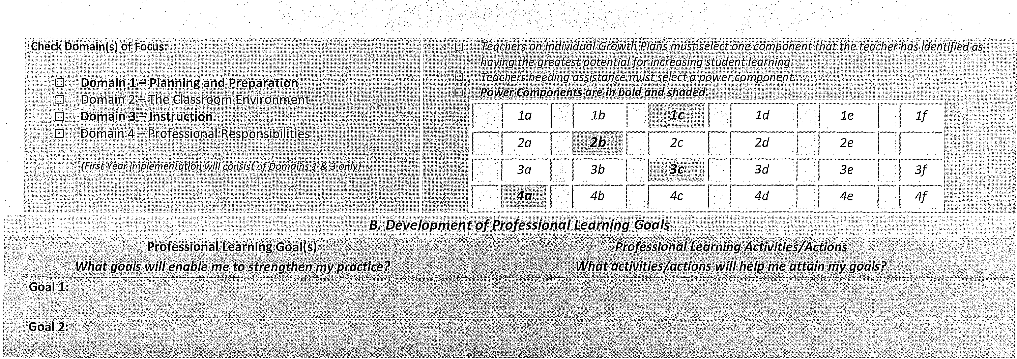
Write a measureable goal to indicate expected improvement insti.tdent achievement. (This is a SMART* goal that aligns with the Schoof Improvement Plan- see the final page of this document for a complete explanation of SMART goals}; · ·
Approval to Proceed with Growth Plan
Administrator/Supervisor Signature Date

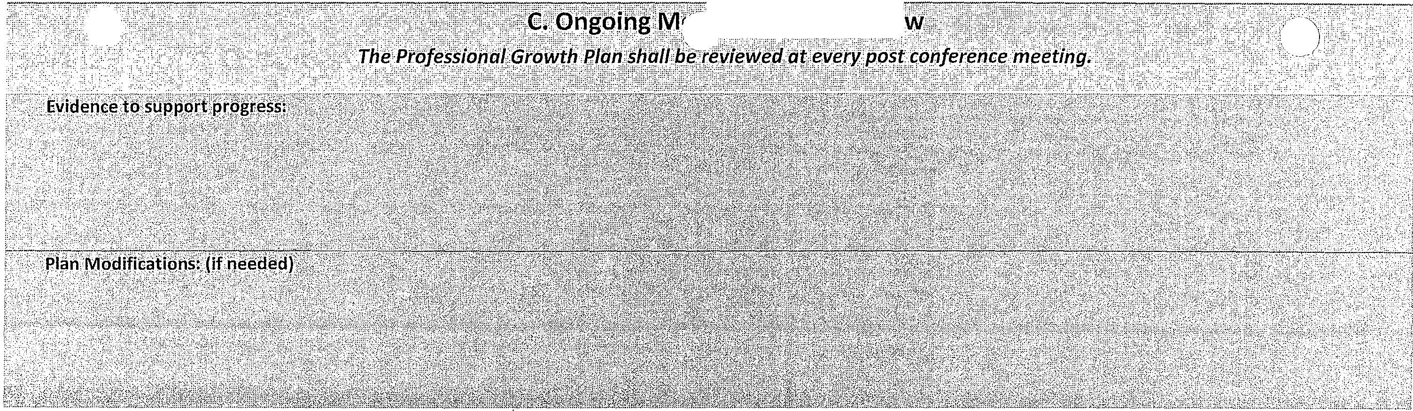
,itPrJ :g/:: ,,r;ij:!:· yt:i·w::':::···:·
Monitored and Reviewed by

Date(s) _

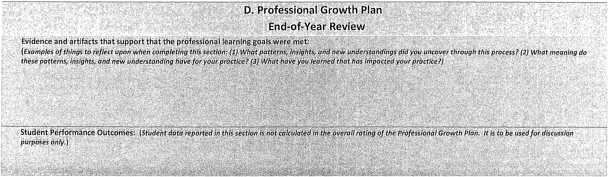

3

Highly Effective

2
Effective

1

Developing/Needs Improvement

0

Unsatisfactory

The Professional Growth Plan demonstrated a direct correlation to needs indicated by student learning data and the educator's previous performance rating, credentials and/or self-inventory. Strategies were specific, fully-developed and focused on improving or changing professional practice for the purposes of improved student learning. The educator reviewed his/her plan during the school year, and readily adjusted the plan when ongoing evidence indicated the need. The educator not only completed all activities identified in growth plan, but identified strategies and resulting evidence that ultimately improved or changed the educator's practice in an effort to improve student learning._The educator's reflection provided extensive and thorough evidence of why the educator implemented those strategies and how and why the chosen strategies improved or changed his/her practice. In the course of implementing the plan, the educator collaborated with other educators in a deliberate and meaningful way. Results of the plan were effectively shared with the wider school community and impacted the pra_ctice of others.
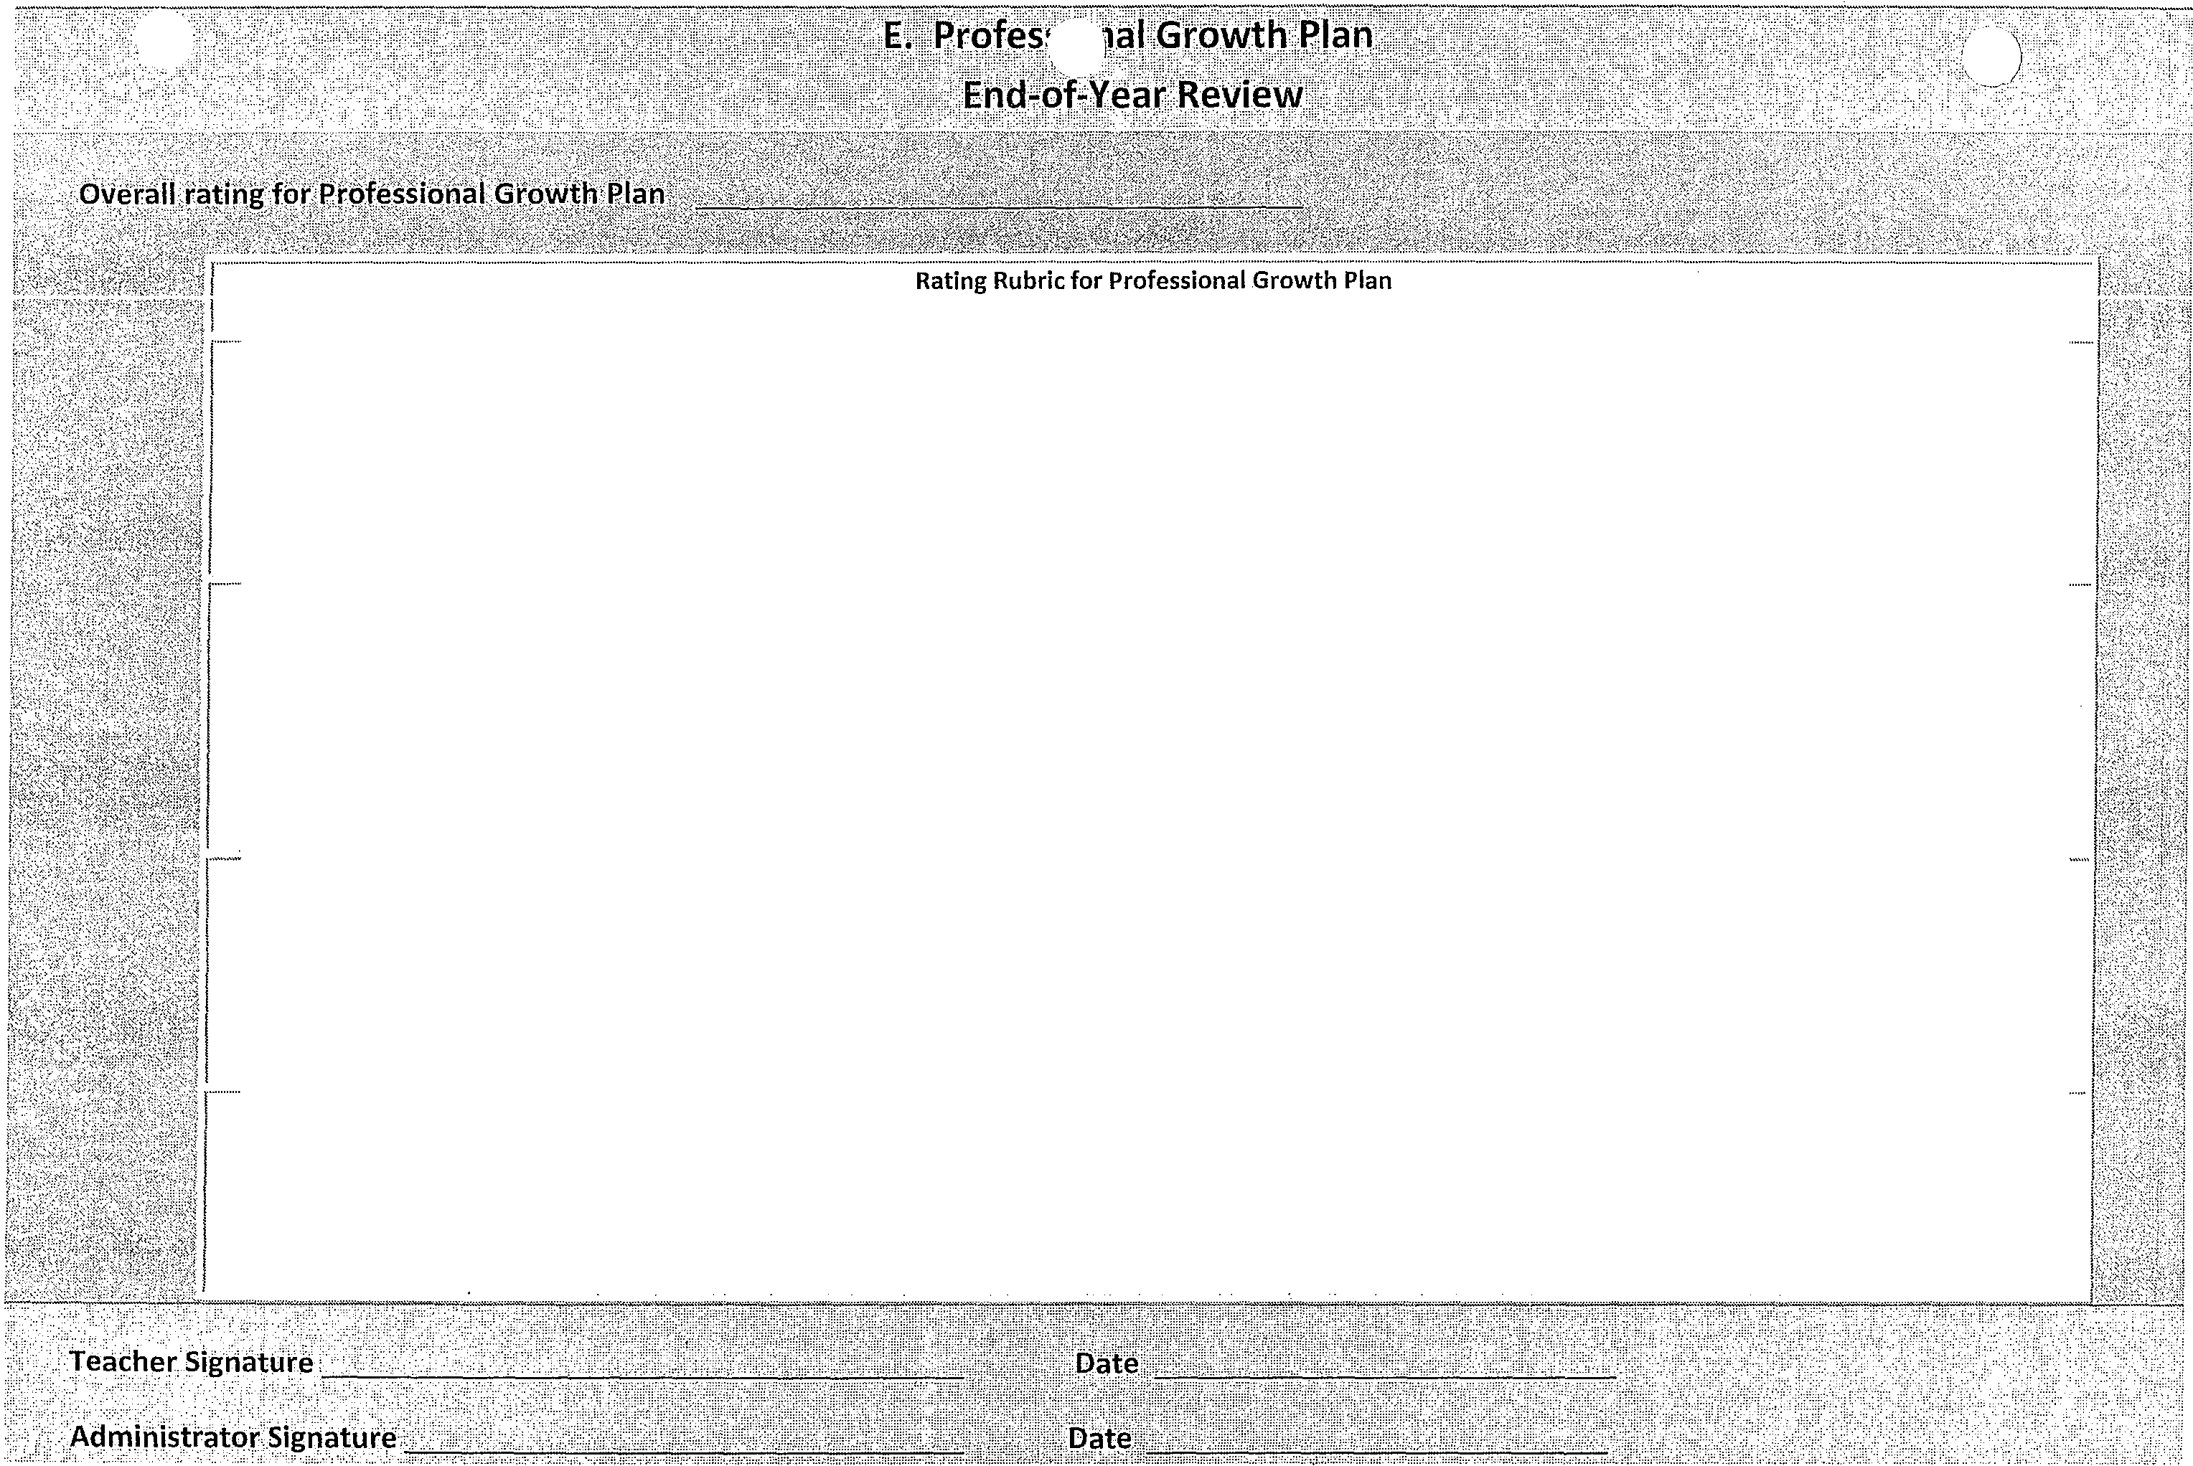The Professional Growth Plan demonstrated a direct correlation to needs indicated by student learning data and the educator's previous performance rating, credentials and/or self-inventory. Strategies were specific, well-developed and focused on improving or changing professional practice for the purposes of improved student learning. The educator reviewed his/her plan during the school year and, if necessary, made adjustments to the plan. The educator completed all activities identified in growth plan and produced evidence that identified strategies were implemented in the classroom. The educator's reflection made adequate connections between student data and the strategies the educator chose to implement. In the course of implementing the plan, the educator collaborated with other educators in a meaningful way. Results of the plan were shared with departments or grade levels and may have had an impact on some colleagues.

The Professional Growth Plan demonstrated some correlation to needs indicated by student learning data and the educator's previous performance rating, credentials and/or self-inventory. Strategies were loosely-focused on improving or changing professional practice for the purposes of improved student learning. The educator reviewed his/her plan during the school year, but made few or no adjustments to the plan unless suggested by the evaluator. The educator's reflection demonstrated that he/she completed most or all activities identified in the growth plan, but provided limited evidence of implementation or how it improved or changed his/her practice. The educator's attempts to collaborate with others were not deliberate and contributed little to the evidence. Results of the plan were minimally shared with others.

The Professional Growth Plan did not directly correlate to needs indicated by student learning data and the educator's previous performance rating, credentials and/or inventory. Strategies were not clear or did not specifically focus on improving or changing professional practice for the pu1·poses of improved student learning. The educator reviewed his/her plan during the school year but did not recognize or accept the need to make adjustments to the plan. The educator's reflection (if one exists) provided little evidence that the strategies were implemented or how those strategies improved or changed his/her practice. There was minimal or no evidence to support the plan. The educator did not collaborate with ottiers in a meaningful way. Results of the plan were not shared with others.

( -) * SMART is an acronym for:
Specific - your goal should have its expected outcome stated as simply, concisely and explicitly as possible. This answers questions such as; how much, for whom, for what?

Measurable - a measurable goal has an outcome that can be assessed and/or measured in some way.

Attainable - an attainable goal has an outcome that is realistic given the current situation, resources and time available. Goal achievement may be more of a "stretch" if the outcome is tough or there is a weak starting position.

Results-Oriented & Relevant - a results-oriented and relevant goal helps maintain focus on the mission or the "bigger picture."

Time-bound - a time-bound goal includes realistic timeframes. Our timeframes are imposed as an instructional year. Because of this, carefully consider what is attainable within this timeframe.

Examples of SMART Goals

- Every student will show evidence of growth in math number ordering.
SMART Goal= Numeration - (greater than/less than, equal to)
During the 2011-12 school year, all students will improve their numeration skills in ordering numbers using the appropriate math symbol measured by an increase of 15 points on the unit test for Big Idea 1 - Develop an understanding of base-ten numerations system and place-value concepts.

- Reduce levels of non-proficient students by 10% in solving word problems
SMART Goal= Math Problem solving (Numbers & Operations)
During the 2011-12 school year, non-proficient students (as indicated by a unit test for MA.7.5.2 non-routine problem solving) at Sample School will improve non-routine problem solving skills by 5% as measured by an increase in the percentage of students scoring at mastery on the midterm and/or course final.

- Students will show growth in Vocabulary as measured by FAIR.
SMART Goal= Vocabulary
During the 2011-12 school year, non-proficient students (as indicated by the FAIR vocabulary subtest) at Sample School will improve their vocabulary skills by 5% as measured by an increase in the per:entage of students scoring at or above grade-level on the FAIR vocabulary assessments given in APl and AP3.

- Students will comprehend grade level text.
SMART Goal= Reading Comprehension- Literary Analysis - Fiction/Nonfiction
During the 2011-12 school year, non-proficient students (as indicated by the Performance Matters Progress Monitoring Tool) at Sample School will improve their ability to analyze character development by 5% as measured by an increase in the percentage of students scoring at or above "proficient" on Progress Monitoring for Benchmark LA.8.2.1.2.

(-- ! Pre-Observation Form
Either party may request a face to face meeting to discuss the Pre-Observation Form
Pre-Observation Conference Questions (To be completed by the teacher prior to the pre­ observation conference)
Teacher Name: Date: Grade(s) Taught: _

Subject Observed: Duration of Observation: (minimum 30 minutes)

LEARNING GOALS/OBJECTIVE
- What is/are your lesson objectives? (Components lA, lC)

How is/are the lesson objective(s) aligned with state curriculum standards/CCSS?
(Components lA, IC)

What data did you use to design this lesson? How did the data influence the planning of
this lesson? (Components lB, IC, lF)

ASSESSMENT
- How will you know if your lesson objective(s) was/were achieved? (Components IF)

INSTRUCTION
- What teaching strategies will you use to teach this lesson? (Components IA, lD)
Why did you use these strategies and resources? (Components IA, lB, lD)

CONNECTING LEARNING

What is the academic relationship between this lesson with past or future lessons (Why this lesson? Why now?) (Components IA, lE)

OTHER

Please explain any special situations or circumstances of which the observer might need to be aware?

- The observer will provide feedback on this lesson. Are there specific areas you would like the observer to look for/focus on?

Post Classroom Observation Summary (To be completed by principal prior to post-obseNation conference )

Teacher Name: Date: Grade(s) Taught: _

Subject Observed: Duration of Observation: (minimum 30 minutes)

Strengths of the Lesson:

Areas for Development (top 3, in priority order):

( ) Next Steps:

Academy for Positive learning Annual Evaluation Summary Sheet
DOMAIN | WEIGHT | RATING | SCORE | ., |  | DOMAIN | WEIGHT | RATING | SCORE
DOMAIN 1<C', \:ff't' ''{,.. . ·},:, .· <\:; f . ? :)' ",.: •, |  |  |  |  |  | DOMAIN3 ' .· •;. ..·. +<:'.·::-,·},>, '........C? ..; ...·, .. .·)
1a | 4% | 3 | 0.12 | '< ·.•..•,.:.·• |  | 3a | 10% | 3 | 0.3
1b | 4% | 3 | 0.12 | .:,,·.··,  '·,'.;'''.•·· |  | 3b | 10% | 3 | 0.3
1c | 2% | 3 | 0.06 |  |  | 3c | 10% | 3 | 0.3
1d | 2% | 3 | 0.06 | "'')/ |  | 3d | 5% | 3 | 0.15
1e | 4% | 3 | 0.12 | >\ ·,,,,•, |  | 3e | 5% | 3 | 0.15
lf | 4% | 3 | 0.12 | ,.":;,'
 |  |  | 0.6 | ?h/). |  |  |  |  | 1.2
·t.t>OMAIN''.2\}.,C:IF'.i'"'"·"t'•"·'',"','·,>/,/•:,·::•• ··::,;>'•':'\'i:i;:it'.;;'C:1;-i{:t••••::;\,'N:••,• ·,·; |  |  |  |  |  | .DOMAIN4\:°\)Lt/,•\)';;':)}'j'!;·{\;: .C" /:,c'ti. :'?}.· :
2a | 5% | 3 | 0.15 | }';(:·!
 |  |  |  |  |  | 4a | 3% | 3 | 0.09
2b | 5% | 3 | 0.15 | (f;?: |  | 4b | 3% | 3 | 0.09
2c | 2.50% | 3 | 0.075 | jI)r\; |  | 4c | 4% | 3 | 0.12
2d | 5% | 3 | 0.15 | \:'{:}.> |  | 4d | 3% | 3 | 0.09
2e | 2.50% | 3 | 0.075 | Ni:i |  | 4e | 3% | 3 | 0.09
 |  |  |  | :::0 | Ti | 4F | 4% | 3 | 0.12
 |  |  | 0.6 | llI | {Jl;i |  |  |  | 0.6

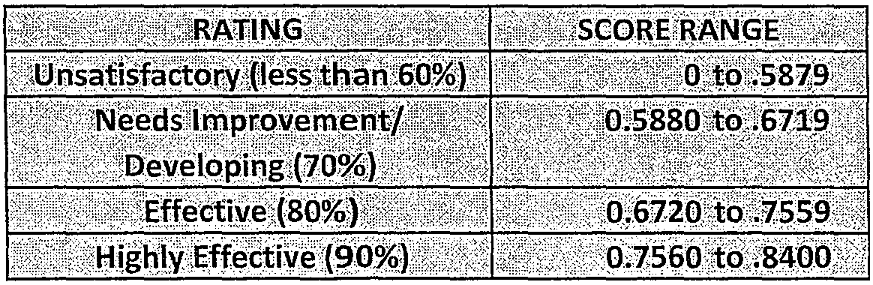
*For school year 2012-2013 only Domains 1 & 3 will contain scores.
\  )  DOMAIN |  | TOTAL SCORE | WEIGHTED  DOMAIN  SCORE
DOMAIN 1
TOTAL | 20% | 0.6 | 0.12
DOMAIN 2
TOTAL | 20% | 0.6 | 0.12
DOMAIN 3
TOTAL | 40% | 1.2 | 0.48
DOMAIN 4
TOTAL | 20% | 0.6 | 0.12
WEIGHTED DOMAIN SCORE GRAND TOTAL |  |  | 0.84

PGP/ IPDP Rating= 30% of Total Evaluation
Highly  Effective | Effective | Needs Improvement/  Developing | Unsatisfac  tory
3 | 2 | 1 | 0

Levels of Performance:

o Unsatisfactory .
o Needs Improvement/
Developing
o Effective
o Highly Effective

o By checking this box, I am indicating that I have read this report.

Signature of Teacher Date:

1ature of Administrator Date:

Academy for Positive Learning
) Annual Evaluation Summary Form

Name: _
School: _
Date: _

Value Added Measure (VAM} to be used (Check one and provide the score)
- | Individual
 | School
 | District

Professional Growth Plan (PGP)
Comments:

Iindividual

Admin. Initials

Individual. Initials

,Please provide a print-out from PBCSD Form 1759 and attach it to the end of this document highlighting those professional development activities
.
\
pat support your Professional Growth Plan.
/'
Other supporting information {e.g., training/professional development) :

Disclaimer: During the SY 2012-2013 Domain 1 and 3 will total 100% of the overall rating on the Evaluation Instrument. Beginning 2013-2014, ALL Domains will be evaluated.
Individuals have an opportunity to comment:

r,eacher Name:
FINAL Annual Evaluation Form
Date: _

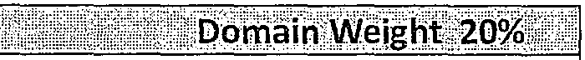
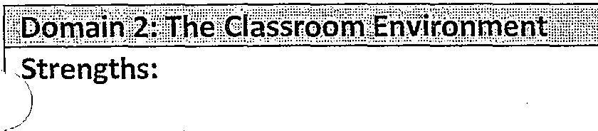
)q rn i11'.1':)Pt hhitj'gln'd}irepraiiOq::1':
Strengths:
Areas for further development: (unsatisfactory rating requires description of deficiency)
Levels of Performance:  D Unsatisfactory | D Needs Improvement/ Developing | D Effective | D Highly Effective

Areas for further development:
Levels of Performance:  0 Unsatisfactory | 0 | Needs Improvement/ Developing | 0 Effective | 0 | Highly Effective

f
Strengths:

_)
Areas for further development:
Levels of Performance:  D Unsatisfactory | D Needs Improvement/ Developing | D Effective | D Highly Effective

\

Strengths:
Areas for further development:
Levels of Performance:  D Unsatisfactory | D Needs Improvement/ Developing | D Effective | D Highly Effective

''- ...

